Act II Scene 1 – Exploring Sound and Hearing
Name
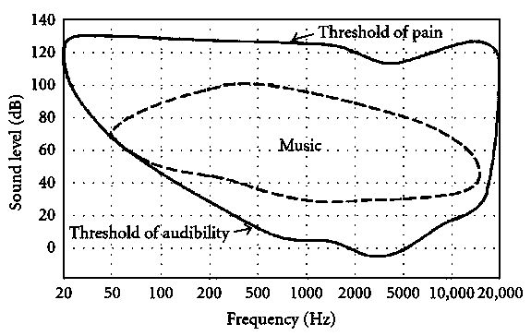
Use the chart at the right for the first four questions.
- Could you hear a 100 Hz sound at 20 dB? No
Yes Correct Answer No
- Could you hear a 1000 Hz sound at 20 dB? no
Yes Correct Answer Yes
- Based on the chart, a 2000 Hz sound at zero dB is right on the threshold of audibility, and so is a 12,000 Hz sound at 20 dB. How much more intense is the 20 dB sound than the one at zero dB?
They are the same intensity.
Answer: The 20 dB sound is 100 times more intense
The 20 dB sound is 10 times more intense.
The 20 dB sound is 20 times more intense.
The 20 dB sound is 100 times more intense.
- Again based on the chart, how would you judge the apparent loudness of those two sounds(2000 Hz at zero dB and 12,000 Hz at 20 dB)?
They would seem the same (very faint) loudness.
Answer: They would seem the same (very faint) loudness
The 20 dB sound would seem 10 times louder.
The 20 dB sound would seem 20 times louder.
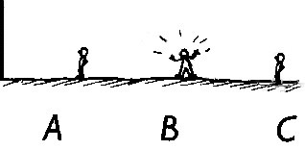
Answer: It depends on the pitch of his voice

The 20 dB sound would seem 100 times louder.
5)
Three guys are standing in a line, 10 m, 20 m, and
30
m away from a vertical wall, respectively. Guy B
shouts. (I wonder why?*) Will he be able to hear his
own echo?

n0

yes

It depends on the pitch of his voice.
* This reminds me of my all-time favorite joke. Choose any three things that can walk, and the more different they are, the better. It’s good if at least one is a priest or a rabbi. Suppose I choose an astronaut, a rabbi, and a duck. Then here’s the joke: “An astronaut, a rabbi, and a duck walk into a bar. The bartender says, ‘What is this, some kind of joke?’”
For all of these questions, use the internet to find good answers.
- What animal can hear the highest frequencies?
Answer: Greater wax moth, Galleria Mellonella. It can hear frequencies as high as 300 kHz.

- Fungo Squiggly, at the right, is a recurring character in the“Get Fuzzy” comic strip. Follow this link to a Wikipedia page: https://en.wikipedia.org/wiki/Hearing_range According to the table under the heading “In animals,” what is so surprising about the hearing range of ferrets?
Answer: Ferret has the broadest range of hearing. It can hear sounds as low as 16Hz up to 44kHz. While other animals can hear only low sounds or only high sounds, the ferret seems to be the only animal that can hear both.
–
getfuzzy.wikia.com
- Again from that same table, what do most birds seem to have in common about their hearing?
Answer: Most birds seem to start being able to hear sounds around 200Hz and up to 8 – 12 kHz mark. We can therefore conclude that birds are unable to hear super high pitched sounds.

Answer: 331.5m/s
– deviantart.com
9)
How fast does sound travel (in m/s) in dry air at
zero Celsius?
10) Who was one of the first people to measure the speed of sound? When was that?
Answer: Marin Mersenne was the first to measure the speed of sound in air (1640)
Act II Scene 2 Homework – Exploring Harmonics
Name
For each of the ‘frog-on-a-post’ waves on the left, match it with the Fourier analysis graph of that wave on the right and with the source, at the bottom. (Hint: Refer to the PowerPoint show, Interpreting Sound Spectra.)
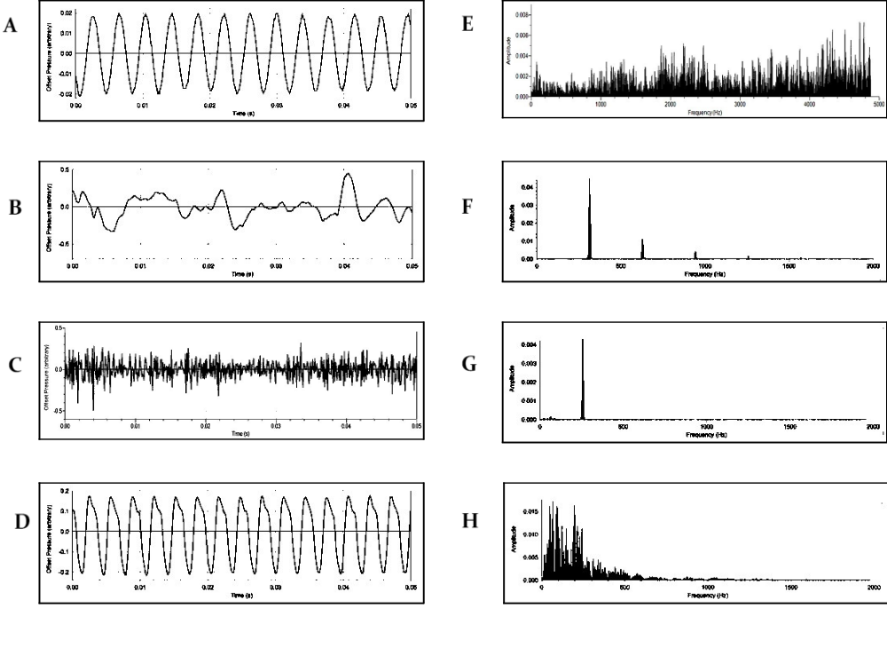
- Which two are of a tuning fork? 3) Which two are of an office fan?
A. E. B. F. C. G. D. H. A. E. B. F. C. G. D. H.
Answer: A and D
Answer: B and F

- Which two are of an organ pipe? 4) Which two are of a person hissing an ‘ssss’ sound?
  - E. B. F. C. G. D. H. A. E. B. F. C. G. D. H.
Answer: C and E
Answer: H and G

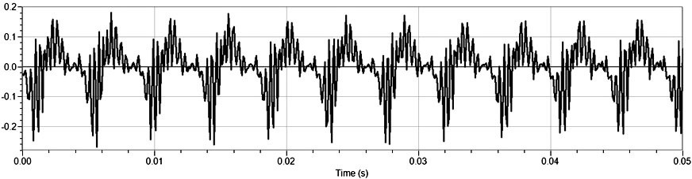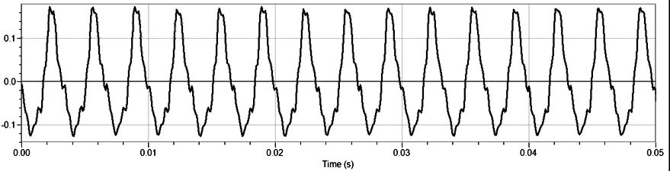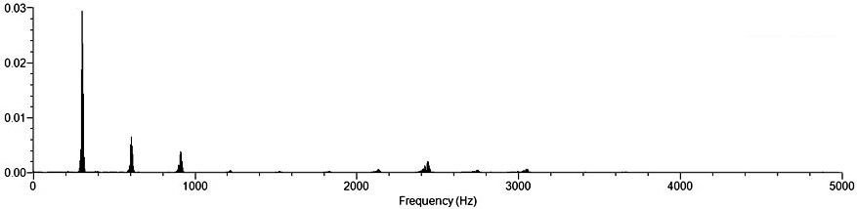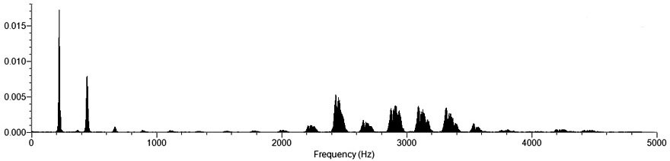The graphs above show the frog-on-post graph and the Fourier analysis of the speech sounds ‘oooh’ and ‘eeeh,’ one in the left column, and the other in the right.
- Which pair is the ‘oooh?’
- the left pair
- the right pair
The correct answer is the right pair.
- How do you know which pair is the ‘oooh?’
Answer: Oooh is very simple sound and Eeeh is much harsher as reflected on the graph. In the Eeeh graph, there are more waves than in the Oooh graph and this help determine the different graphs.

- Which pair of graphs shows a sound of a higher pitch? (Hint: Which harmonic determines the pitch?)

- the left pair

- the right pair
The correct answer is the right pair.

- How do you know which pair is the higher pitch?
Answer: Frequency determines the pitch of a wave. Therefore the higher the frequency, the higher the pitch will be. The graph on the right has a slightly higher frequency than the graph on the left. The graph on the right has a higher pitch.

- For four points, from the graphs above and the Interpreting Sound Spectra PowerPoint show, explain why it’s important that human hearing is most sensitive between about 2,000 and 4,000 Hz.
Answer: This is because between 2000 to 4000 Hz is the hearing range for humans. If the array is below 2000Hz and above 4000Hz, they would not be able to hear each other.

